**Plasma Donor Application**

**Category :** Cloud Computing

**Industry Mentors :**

Sowjanya

Sandeep

**Faculty Mentor:**

C. Angel

**Team leader :**

A.Gnana Abina

**Team Members :**

M. Indhuja

C. Ashika

M. Geetha

**Use case:**

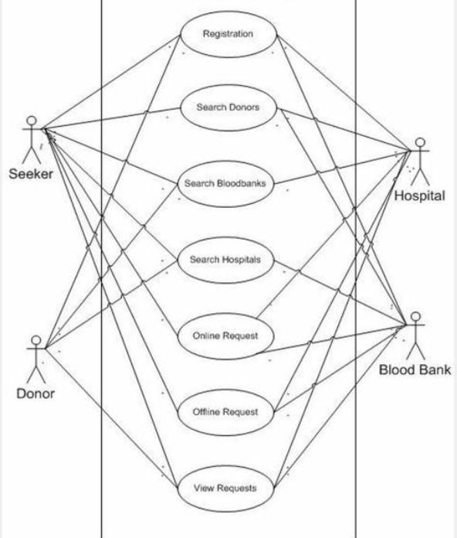 This application is to developing an online blood donation information.

The blood donation agent is to create an information about the donor and organization that are related to donating the blood.

This system is used for maintain whole information about donors,receivers,camps.

**Novelty:**

Plasma donation are used for slightly more specific purpose then a general blood donation. The most common uses of plasma donations include individuals who have experienced a severe trauma, burn or shock, adults or children with cancer, and people with liver or clotting factor disorders.

**Feasibility of Ideas:**

Drink 4-6 eight-ounce glasses of water, fruit juice or other caffeine-free liquid at least 2 or 3 hours before donation.

Avoid caffeinated beverages.

Avoid alcohol of any type for 24 hours before you donate.

Eat a meal prior to donation.

Get adequate sleep.

**Business Model :**

Many of these plasma centers are subsidiaries of profitable publicly traded life science companies, so the money donors receive comes from the companies themselves. Bio life plasma services, with a location in Greenville, is a subsidiary of to key-based takes, one of the 20 largest.

**Scalability of the solution :**

Blood banks around the world often struggle to collect sufficient quantities of blood ,Plasma, and other blood components to meet the needs of the large and growing number of patients who rely on transfusions and blood -derived therapies for their survival.